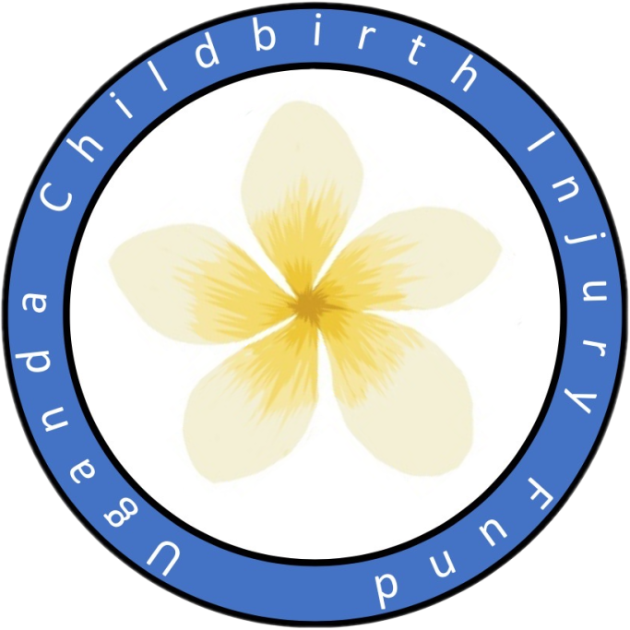

UGANDA CHILDBIRTH INJURY FUND NEWSLETTER 2024

We are a charity dedicated to helping women who have suffered permanent injuries during childbirth.

Please visit our website UCIF.co.uk

Registered UK Charity No 1099135

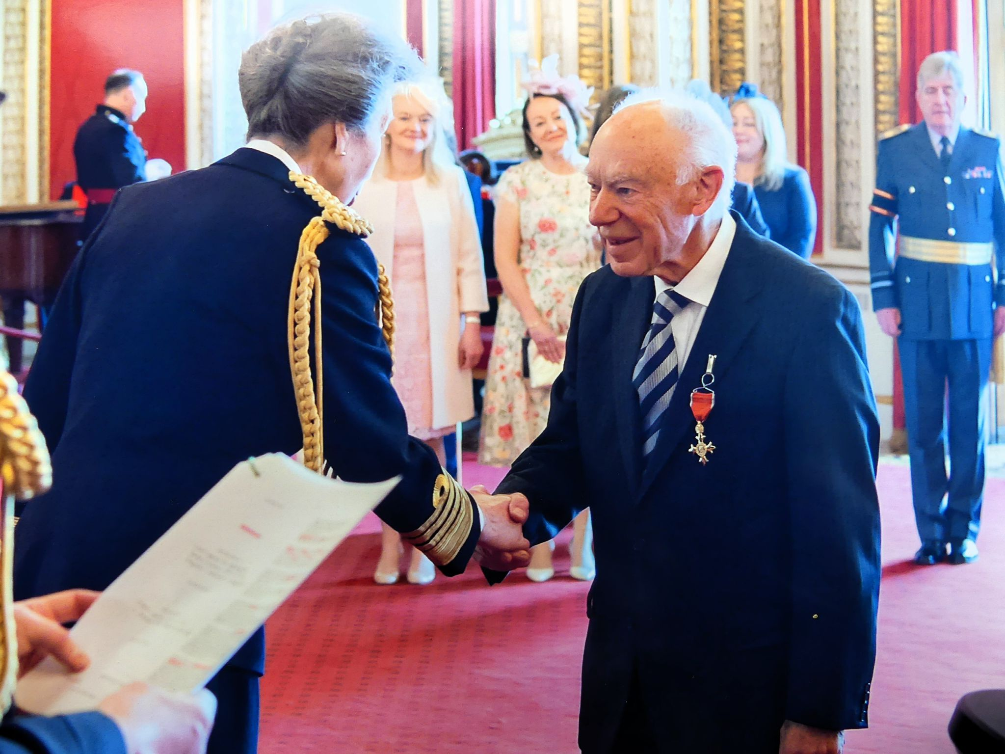

Dear Friends & Supporters This has been a good year for UCIF.

Our co-founder and mentor Brian Hancock was awarded OBE for services to surgery in sub-Saharan Africa, a reward which could not be more deserved.

Workwise, since the last report in Oct 2023, we have run nine and supported four surgical camps. A further two are planned before the end of the calendar year. Our Ugandan colleagues (Dr Asiimwe, Dr Matovu and Prof Baregeine) are undertaking more and more of the work, with four senior trainees becoming ever more confident – Dr Fiston, Dr Tinka, Dr Tino and Dr Franka. We were very pleased to welcome Dr Paul Muwanguzi to the team.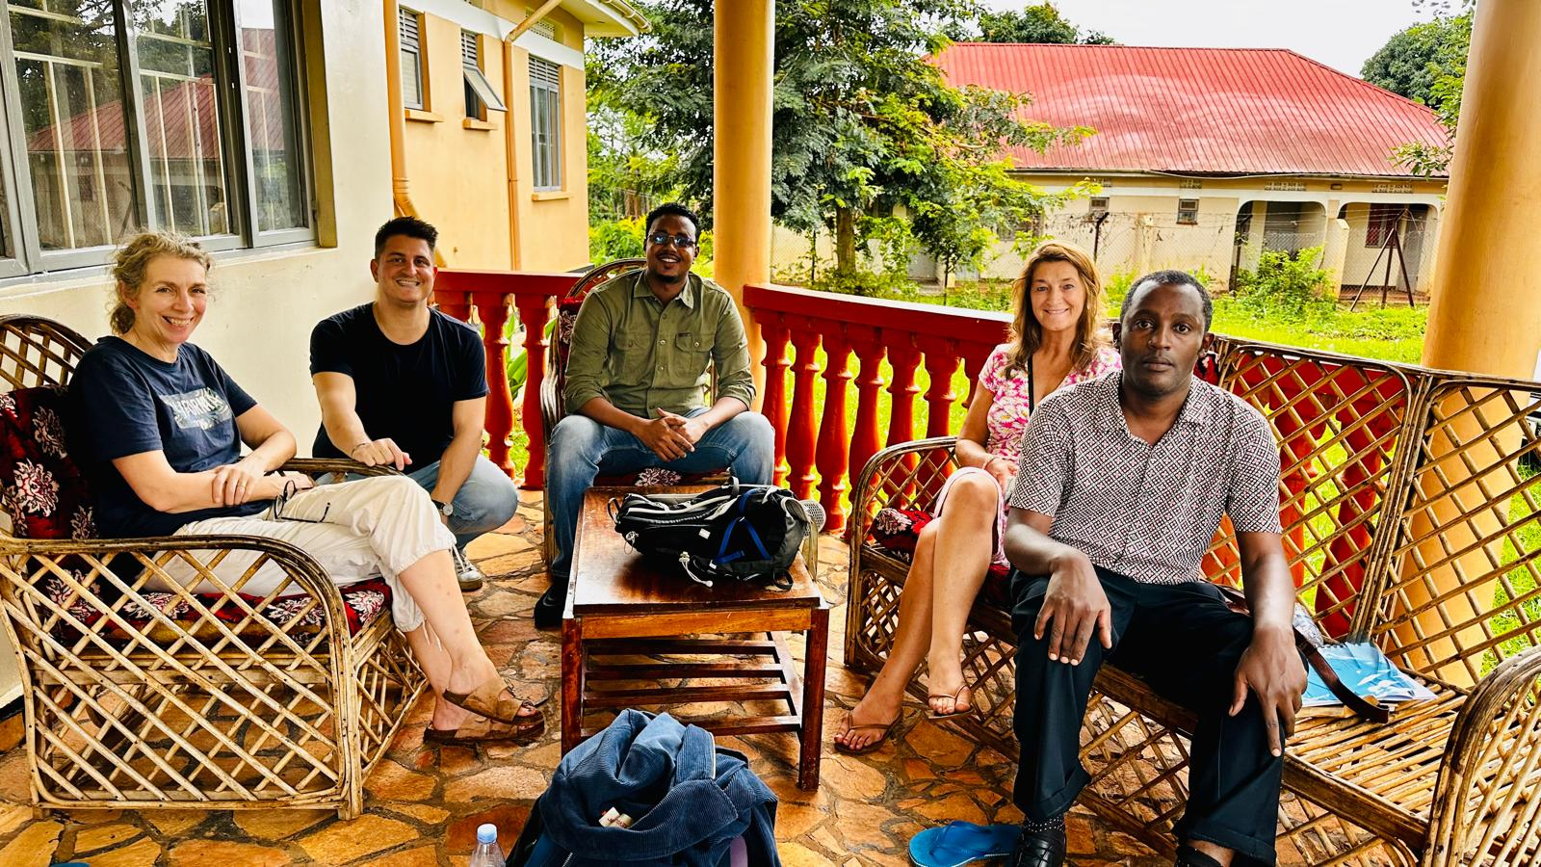

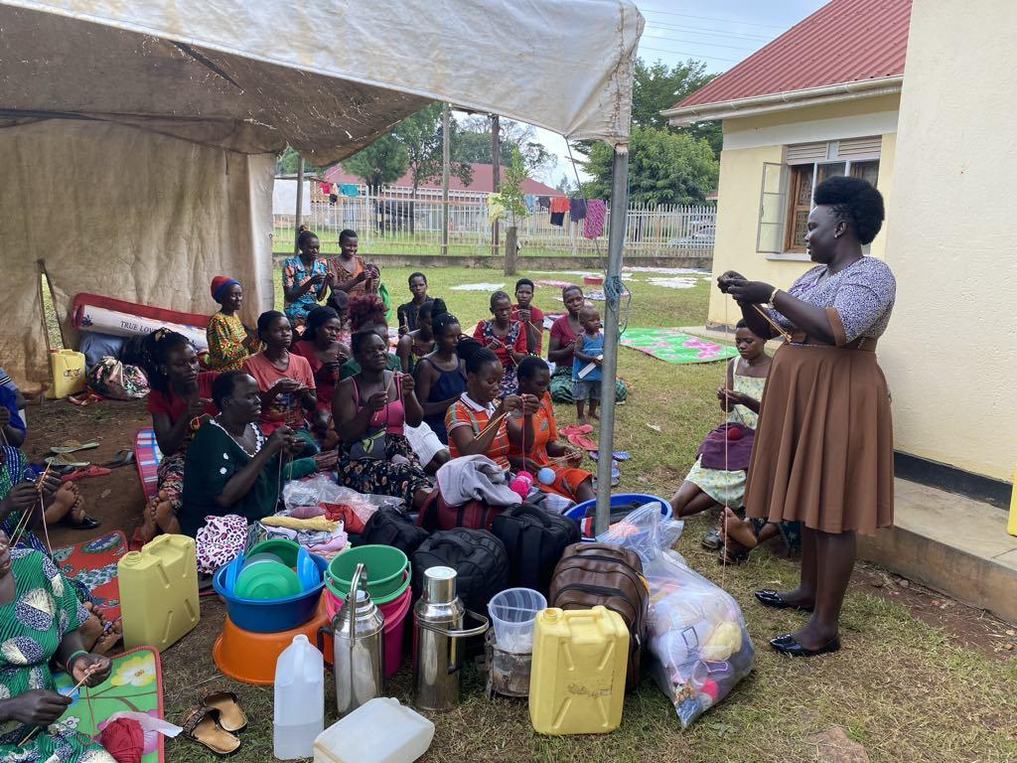

We have treated 258 women and girls affected by childbirth injury and incontinence.The women remain central to what we do and we are grateful to them for allowing us to use their pictures. This photo shows some of the women post operatively knitting as they are recovering from surgery.

It is hoped that UCIF will fund 5 camps in Uganda in the next financial year. Ugandan surgeons will be the primary operators running each camp, with Dr. Collie and Dr Darlow planning to attend 3 camps to lend support and help with teaching.

Dr Collie travelled to Toamasina in Madagascar to cover the fistula unit there while Dr Breen was away. She undertook 18 operations, of which 16 were complex difficult primary obstetric fistula.It was noted that there are very many primary obstetric fistula in Madagascar, with very few women being delivered in clinics or hospitals. The cost of healthcare is beyond the majority of the population.

Additionally, there have been 6 nurse training programs run by Ishbel Campbell and her Ugandan team in Uganda, and one in Angola. We believe investing in the local staff is key to achieving the best outcome for the women in recovery. Christine Wood plans to implement midwifery training as part of preventative work.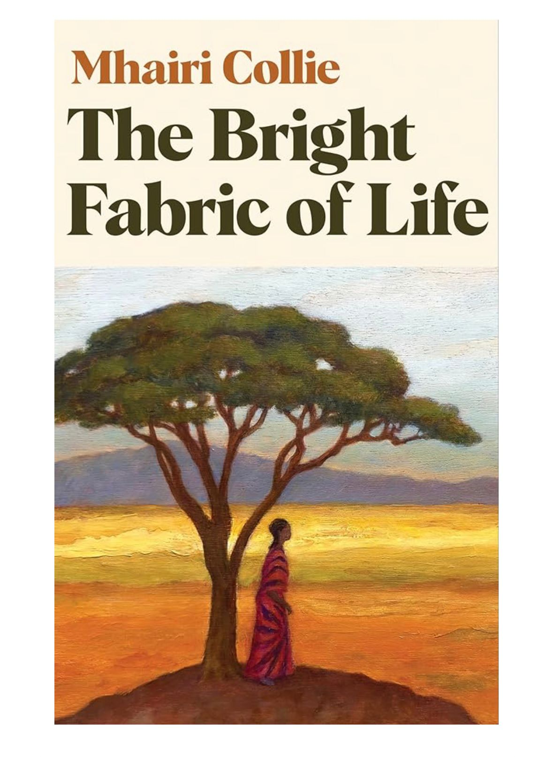

In addition to all of Mhairi’s clinical contributions she has managed to write the novel “The Bright Fabric of Life”. It’s a brilliant read and takes you to the heart of what it means to be a fistula sufferer and gives an insight to the work our charity does.

Available at: <https://shorturl.at/iIbkI>

Wishing you all a very Merry Christmas and a joyous New Year.

Love Brian, Mhairi, Kate, Ishbel, Christine and Sarah

Trustees: Brian Hancock, Mhairi Collie, Kate Darlow, Ishbel Campbell, Christine Wood, Sarah Fraser

Office address: Sarah Fraser (Treasurer) 2 Murrayfield Road, Edinburgh, EH12 6EJ Email: [ugandachildbirthinjury@gmail.com](mailto:ugandachildbirthinjury@gmail.com)