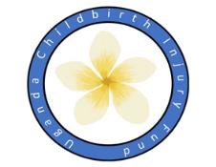

UGANDA CHILDBIRTH INJURY FUND NEWSLETTER 2023

A charity to cure by surgery women made incontinent through complications in childbirth and surgical procedures. Please visit our website UCIF.co.uk

Registered UK Charity No 1099135

Dear Friends & Supporters

This year has been busy for UCIF with a total of 8 camps since our last newsletter. These camps have taken place in Kyangwali Refugee Settlement, Kitovu Mission Hospital, Kuluva Mission Hospital (outside Arua), Kamuli Mission Hospital, St Anthony’s Hospital, Tororo and Kagadi General Hospital.

A total of 302 operations were undertaken including fistula repair, 3rd and 4 th degree tears and operations for stress incontinence. The constant throughout all these camps was Dr Ian Asiimwe, our Ugandan colleague, supported by Dr Collie Dr Darlow and Dr Reimers with Ishbel Campbell and Christine Wood supporting our nursing team.

There has been a great emphasis on training, with senior and junior surgical trainees, urology fellows, obstetric and gynecology trainees and many nurses all benefiting from attending teaching camps.

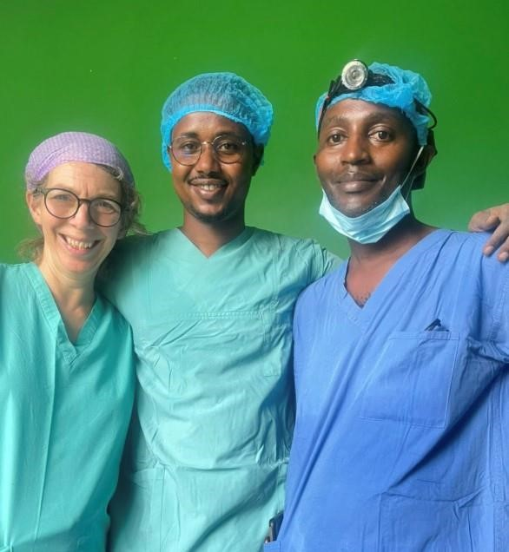A visiting senior surgeon from Somalia, Dr Abdi, joined us in Kamuli. He said of his experience “During the campaign, I had the opportunity to acquire new surgical skills. Working under the guidance of experienced surgeons like Mhairi collie, Ian Asiimwe and Cathrine Reimers. I witnessed and actively participated in fistula repair surgeries. The hands-on experience allowed me to enhance my understanding of the surgical procedures involved in addressing obstetric fistula”.

Figure 1 Dr Abdi (centre) with Dr Collie and Dr Asiimwe

Kamuli had a preponderance of complex abdominal cases but

nevertheless, the outcomes were excellent with no major complications.

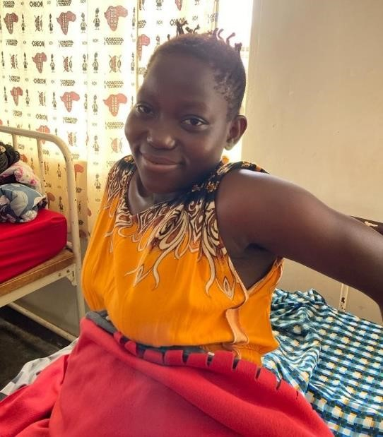The women we care for are central to what we do, and we are grateful to Nangobi Rose who agreed that we could use her photograph. She represents many women we care for who following the birth of their baby are left with vaginal and perineal tears, some which involve the sphincter. This means a life of faecal incontinence for many. Nangobi spoke of her embarrassment and acute awareness of her affliction leading to her not even wanting to engage with her family. With surgery and careful post operative care and planning she is now able to return to her normal life in the village.

Figure 2 Nangobi Rose

Special congratulations to Ishbel Campbell and the Kamuli Nursing team for winning a prestigious Burdett Nursing Trust Award in May.

Having been shortlisted for the ‘Nursing Now’ award for the Burdett Nursing Trust the Kamuli Fistula Nurses won the category and a large grant to continue the nurse training program.

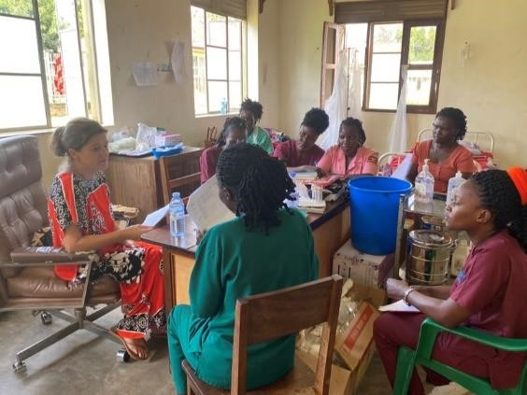The team consisted of Ishbel Campbell, senior UK nurse, Joan Nabbagala, Joanita Musubika and Morris Andama, Ugandan Fistula Nurse trainers, with Dr Ian Asiimwe overseeing the nursing team.

Figure 3 Nurse teaching on the ward at Kamuli

Discussion is currently underway to develop the training and take it to other countries in Africa with high burden of fistula. All care we give is thanks to our ongoing support and we thank you for your part in this, something we never take for granted.

Wishing you all a very Merry Christmas and a joyous New Year.

Love Brian, Mhairi, Kate, Ishbel, Christine and Sarah

Trustees: Brian Hancock, Mhairi Collie, Kate Darlow, Ishbel Campbell, Christine Wood, Sarah Fraser

Office address: Sarah Fraser (Treasurer) 2 Murrayfield Road, Edinburgh, EH12 6EJ Email: ugandachildbirthinjury@gmail.com